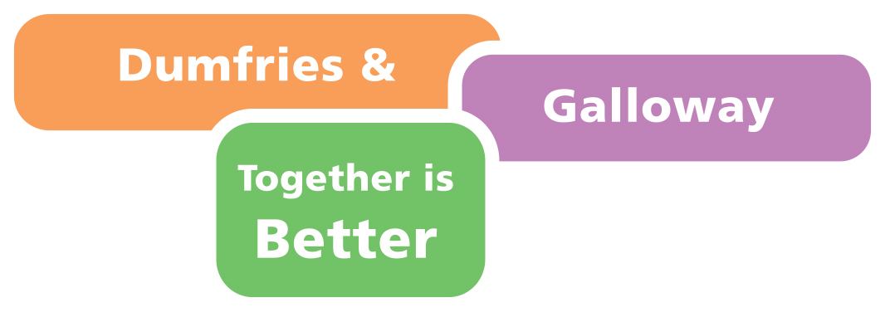

Dumfries and Galloway Children's Services Plan
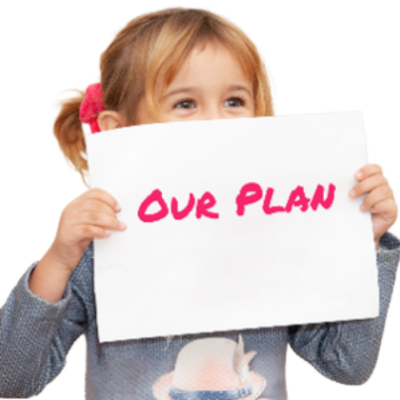 | Our Children’s Services Plan  

What this plan is for
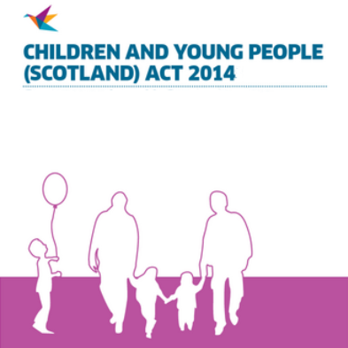 | In Scotland there is a law called the Children and Young People (Scotland) Act 2014.  This law aims to make Scotland the best place for children to grow up.
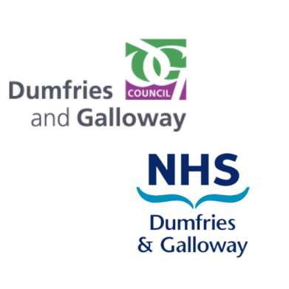 | The law says that local councils must work together with the NHS to make a Children’s Services Plan.
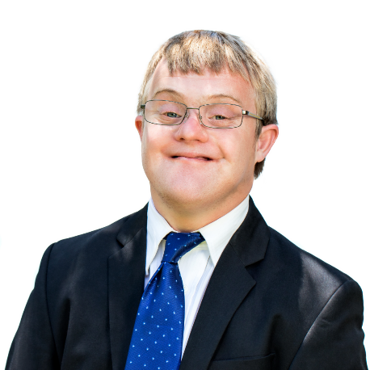 | The plan should say what the Council and NHS will do to help children and young people have better outcomes  Outcomes for children and young people are the way we want to see things turn out for them  Good outcomes are about having a good life, things like:  - Having the best possible health  - being able to go into further education, training, a job, or voluntary work after leaving school.
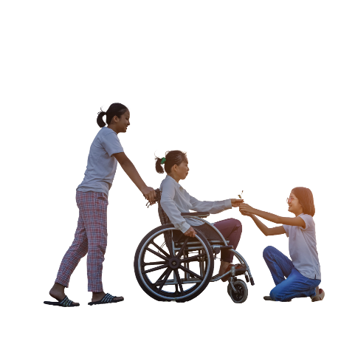 | This plan is about children and young people who might need extra help so that they can have good outcomes.
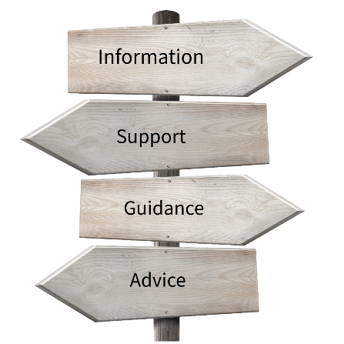 | A Children’s Services Plan should focus on prevention and early intervention so that children, young people and families can have good outcomes.  Prevention means that children and families can get information and support in good time, so they can avoid getting bad problems.  Early intervention means that if children and families do have problems, they can get help as fast as possible before the problems get worse.

Our vision - what we want to see happen
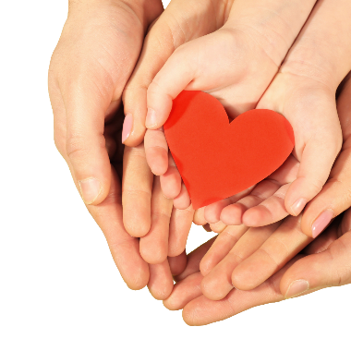  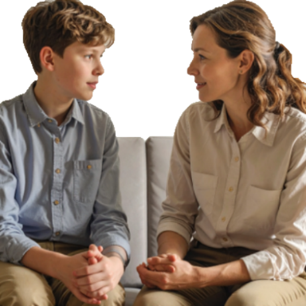  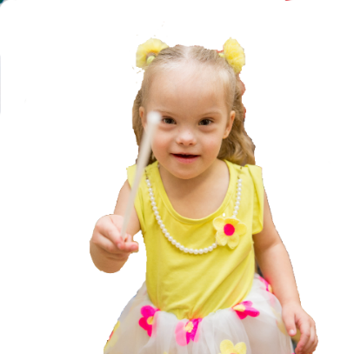 | In our plan we have a vision, this is what we want to see happen.  Our vision is that:  - All children and young people in Dumfries and Galloway will be treated with kindness and love.  - Children and young people in Dumfries and Galloway will be able to talk to adults about what makes them happy or sad in their lives. Adults will listen to what they say.  - Children and young people will be able to live the best life they can.

Our priorities – the things that are most important in our plan
 | In our plan, there are 4 things that are very important.
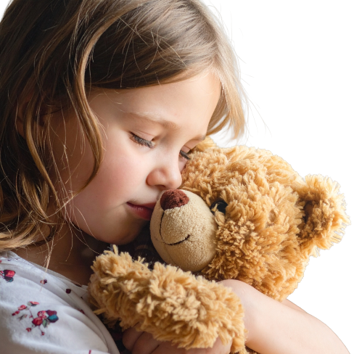 | We want to keep children and young people safe.  This means that they are:  - safe at home  - safe at school  - safe on the internet  - safe in other places, like playing outside and on the school bus  - Safe from being bullied
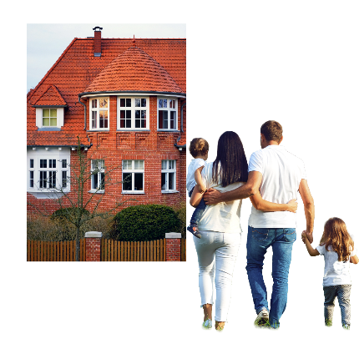 | We want families to get help when they need it.  This means that if parents have problems they can get help quickly.  Problems might be things like:  - Not having enough money for things like food and clothes  - Feeling scared and unhappy and finding it hard to cope  - Not having a safe place to live.
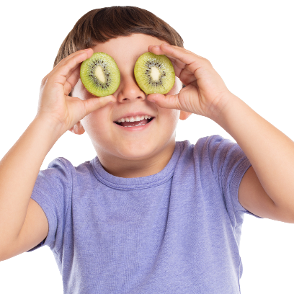 | We want all children to be as healthy as they can be.  Children who might need more help to be healthy include:  - Children with disabilities  - Children who have mental health needs  - Children who have neuro-developmental conditions.
 | We want all children to be able to go to school and learn. Some children find school hard because they have mental health needs or other needs.

What we will do
 | Each of these priorities has its own plan that says how we will make the priority happen.  In all these plans, lots of different services will work together.  Different services include:  - Schools  - Health services like nurses and mental health workers  - Youth workers  - Social Workers  - Police Officers
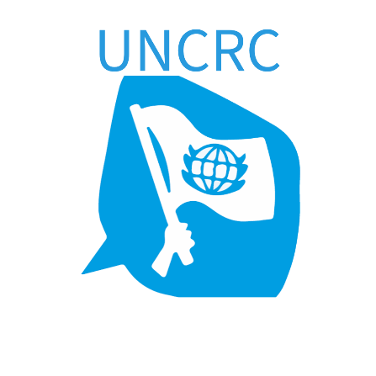 | The United Nations Convention on the Rights of the Child or UNCRC is an agreement that countries will protect human rights for children and young people.  In Scotland the law says that public services like the Council and NHS must respect the rights of all children and young people. We will make sure that we do this.
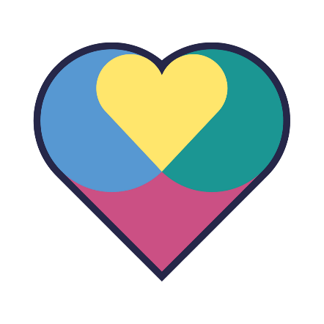 | The Promise  The promise is “that all Scotland’s children and young people will grow up loved, safe and respected so they can realise their full potential.”  The things we will do in our Children’s Services Plan will help us keep this promise in Dumfries and Galloway.

How we will know if our plan is making a difference
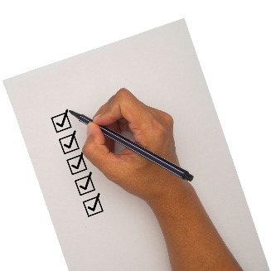 | We will check whether all the things in our plan are being done.  We will ask children and young people if they think the things we are doing are making a difference to them.
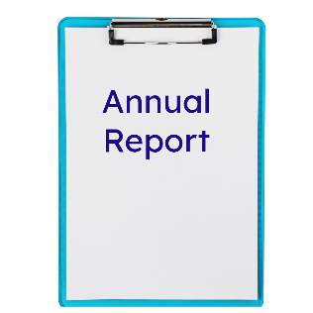 | We will use this to write a report on our plan. We will publish this on the Council website.
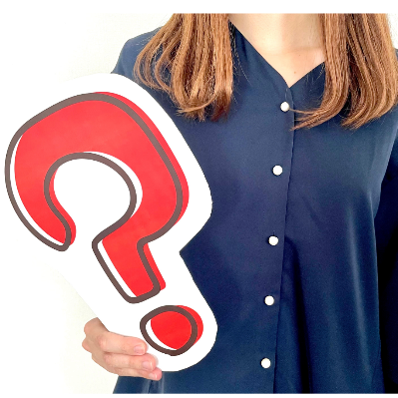 | To find out more about our children’s services plan, email childrensservices@dumgal.gov.uk

