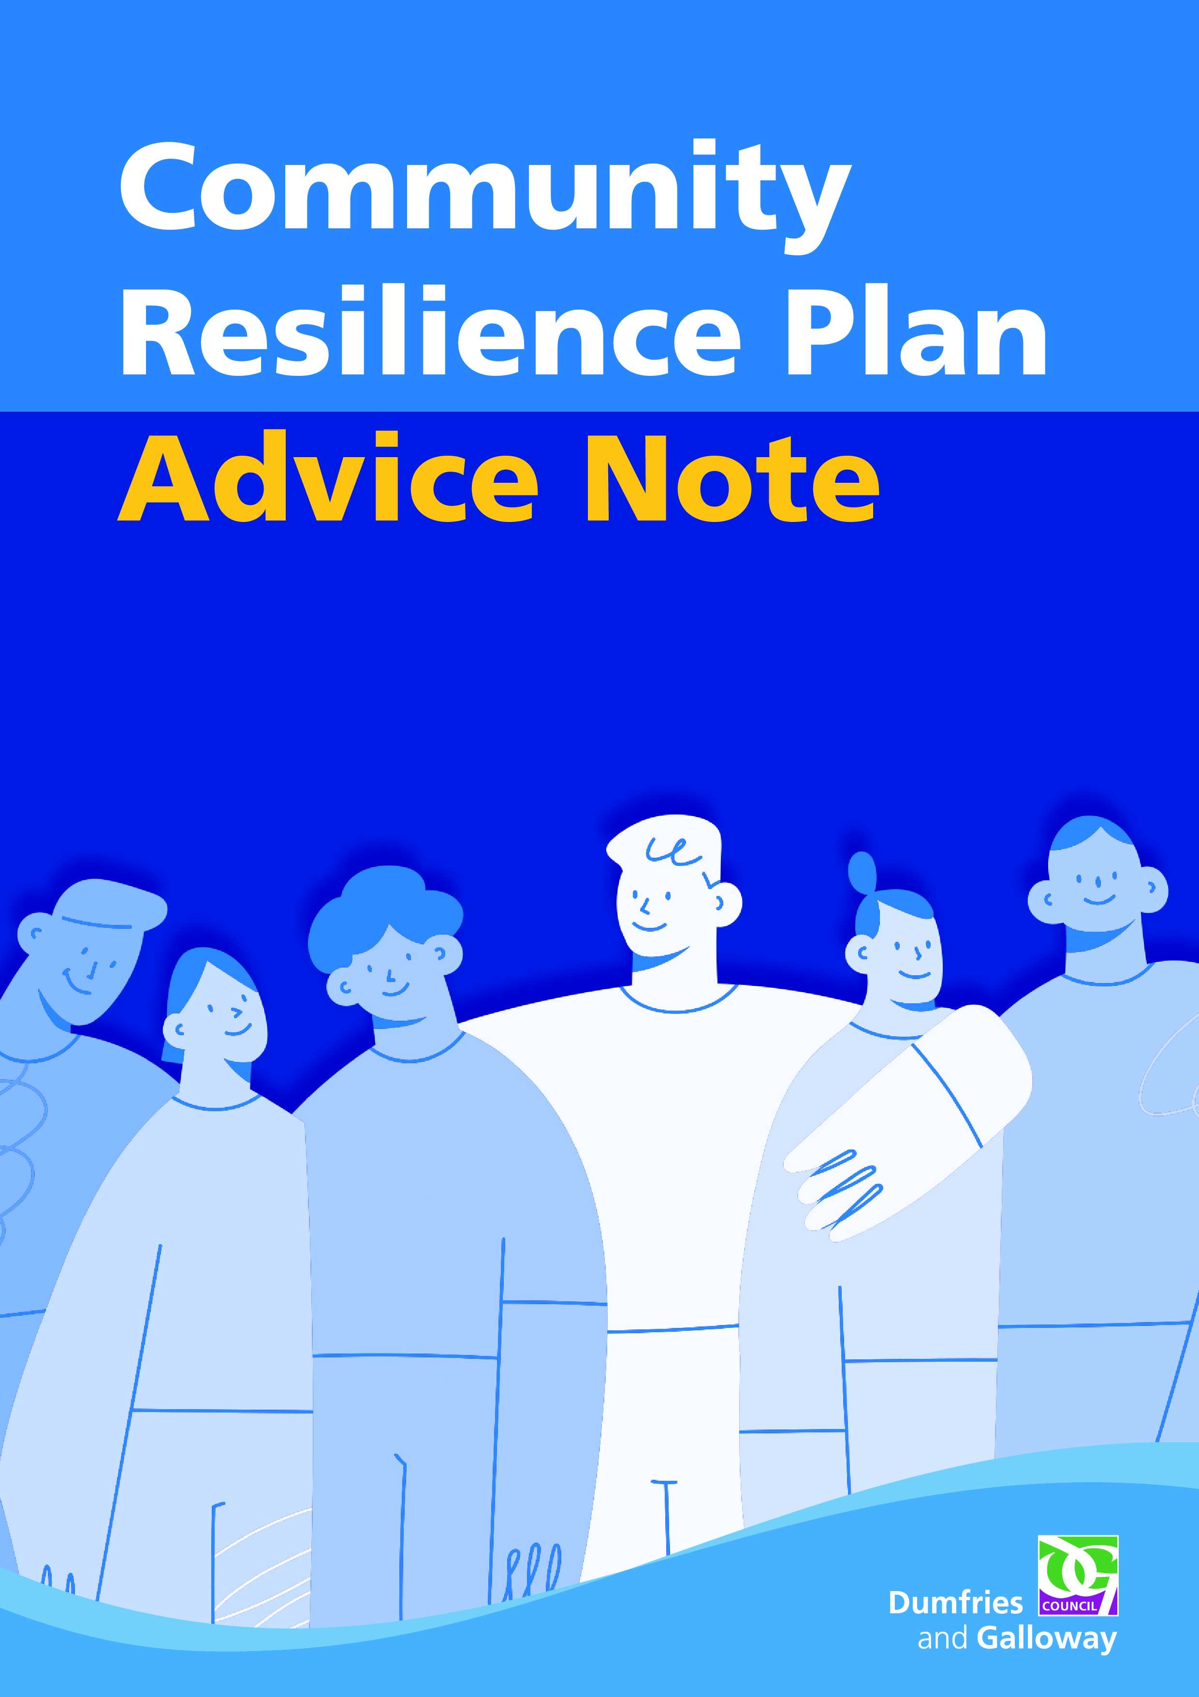
Advice Note
The purpose of this document is to compliment the Community Resilience Plan template and provide you with advice and guidance on how to fill in each section of the plan.
Front Page of the Plan
The front page of the plan should contain basic information about your resilience plan and group.
Insert Group Name Here – The name of the group is down to the members to decide. Some examples of how existing groups are named are listed below:
- Village/town Name Community Resilience Group
- Town Re-development Trust Community Resilience Group
Group Status – In the box that says ‘we are community council affiliated/an independent group’ please delete as appropriate so that it is clear what the status of your group is.
Population Covered – Please state the population size of your village/town.
Plan Date – Please confirm the date the plan was written.
Review Date – Plans should be updated annually, so the review date should be a year from the original plan date.
Logos – If a Community Council or Community Resilience Group have a logo they are more than welcome to put this on the front page of the resilience plan.

Inside the Plan
- Amendments to Plan
On page one the first part of the plan is the amendment section, where any changes to the plan should be documented. It is important to note who made the amendment, what the amendment is and the date of the amendment.
Amendments can be made at any time and if of significance, for example the coordinator of the group has changed, please share this with the Community Resilience Officer so the information can be updated.
Alternatively, amendments may only be made when the plan is reviewed annually.
- Community Resilience Group
This section is for noting down the key members of your Community Resilience Group. It states which individual is doing which role and is a place to write down their most up to date contact information.
If possible, please include a landline phone number as if signal drops landlines can sometimes be the only method for contacting CRG’s.
- Volunteers
This section is for noting down the individuals in your community who do not wish to be a formal member of the resilience plan and play a role in developing the plan but are happy to assist in an emergency. The reason they may want to assist is because they have resources to help.
- Neighbouring Community Resilience Groups
This table asks for the name of neighbouring community resilience groups and their coordinators details. The reason for this section is so that if there was an emergency neighbouring groups can reach out to each other for support.
The majority of CRG’s are Community Council affiliated so we would encourage you to check the Community Council webpage - Community Councils - Dumfries and Galloway Council to find your neighbouring Community Council Secretary and make contact with them.
It’s beneficial to establish relationships in ‘peace time’ so that in an emergency groups are aware of each other and the existing resources between communities.

- Main Community Facility
This page is about gathering as much information as possible on your community’s main facility. The following information should be captured:
- Location – The full address, including postcode. If possible please include the ‘what3words’ location which can be sourced on the following website - what3words /// The simplest way to talk about location If you needed to call an emergency service you can always give the what3words location for precision.
- Accessibility – Describe what accessible features the building has. E.g. wheelchair accessible, hearing loop.
- Floorplan – only if this is available.
- Capacity – Please advise what the capacity is. Often this number is advised by the Scottish Fire and Rescue Service.
- Wi-Fi – Does your facility have Wi-Fi available?
- Medical/First Aid – Does the facility have a first aid kit and a list of individuals trained to use it?
- Key Buildings
Other important buildings in the community should be noted here, even if your group does not have access to them. The types of buildings may include schools, church halls, churches and other Council owned facilities such as leisure centres.
- Food Provision
This section asks about food provision available in your community. This can refer to shops and supermarkets, restaurants and hotels, local food banks and independent food stores.
- Community Resources
This page asks about the resources available within the community. It is important to write down as much information as possible. For example, if a farmer has a tractor they would be happy to use write down their contact details.
It’s important that the location of the resources are written down, so members know where to find the items if they are required.
Defibrillators - Please put the exact location of defibrillators, including postcode, and what 3 words location.
- Insurance
This page discusses insurance cover for Community Resilience Groups. We would encourage you to attach a copy of your insurance policy to this page for your own reference.
- Key Contact Information
This page provides key contact information that may be helpful in an emergency situation.

- Disclaimer
Please read the disclaimer and be familiar with this.

- Appendix 1. Community Risk Profile
These three pages are to assist groups in identifying risks to their community and what they can do to prepare for, respond to and recover from these potential impacts. There is a lot of guidance within the plan on this but if a group needs support, they can contact the Community Resilience Officer at communityresilience@dumgal.gov.uk.
- Appendix 2. Logging Sheet
During an emergency many actions can be taken. It is encouraged to write the actions down so there is a record of what the CRG did during the event.
- Appendix 3. Community Resilience Debrief Template
This document can be used following an emergency. We encourage all of our CRG’s to carry out a debrief if they activated in an emergency as this exercise can assist groups to establish what went well, what could have gone better and any other learning. This can often lead to amendments within the plan.

