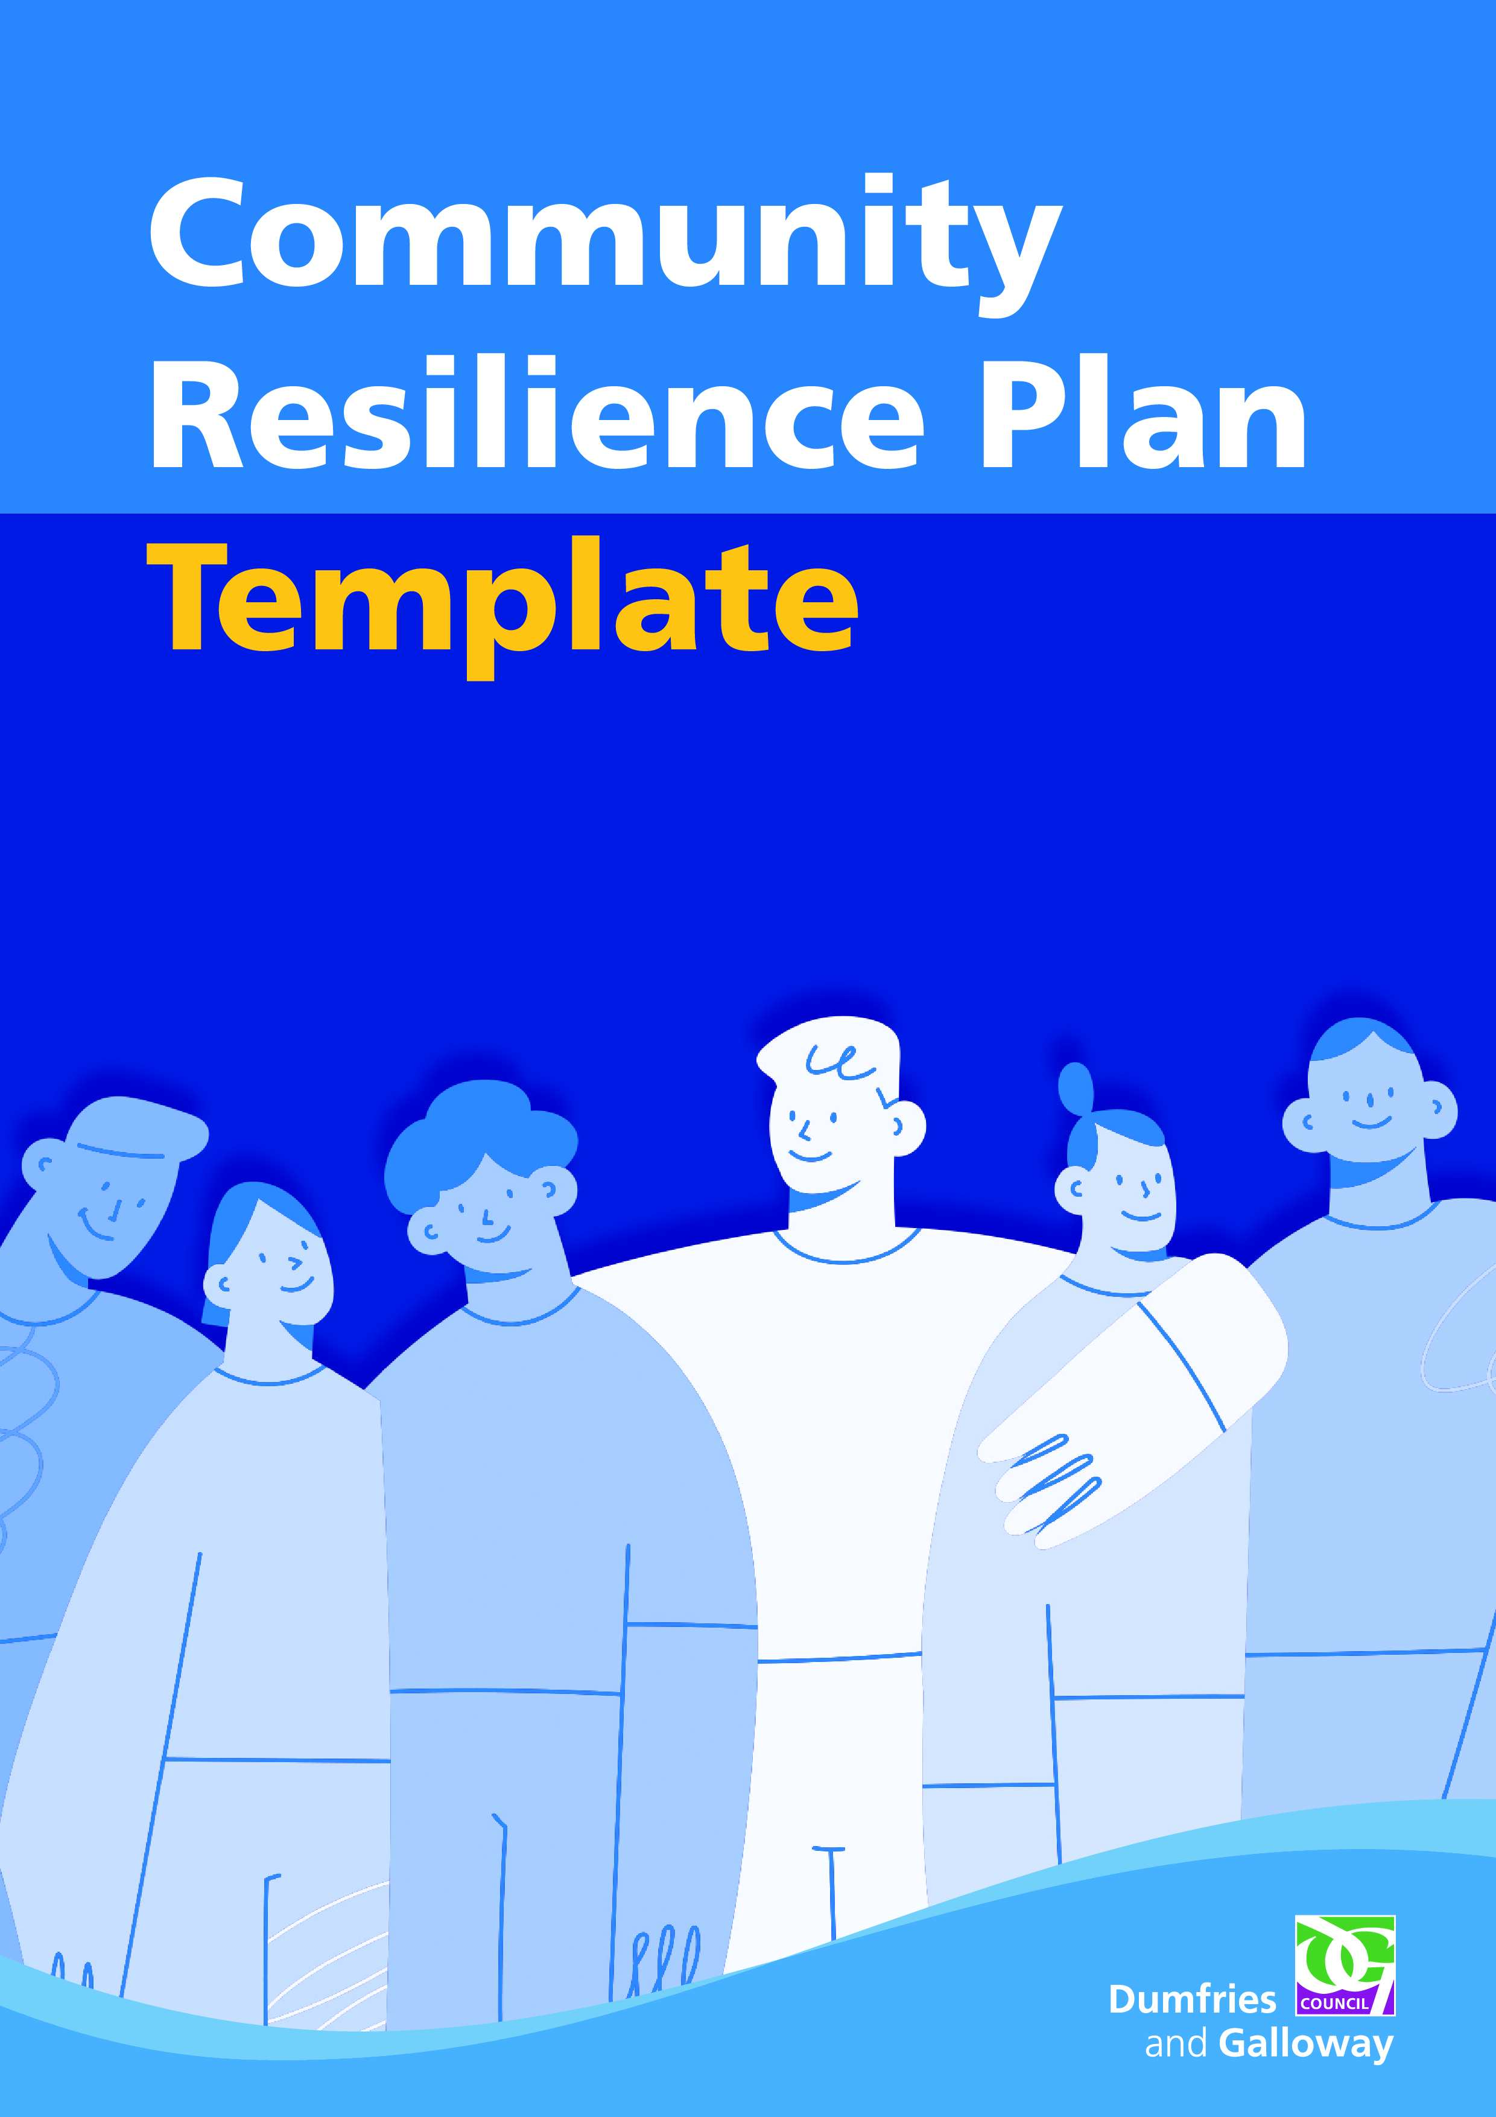
Community Resilience
Insert group name here
Plan

If anyone is in immediate danger call 999

We are Community Council Affiliated/an Independent Group

Population Covered: XXXXX
Plan Date:
Review Date:



Contents
Amendments to Plan 2
Community Resilience Group 3
Volunteers 3
Neighbouring Community Resilience Groups 4
Main Community Facility 5
Key Buildings 6
Food Provision 6
Community Resources 7
Insurance 8
Key Contact Information 9
Disclaimer 11
Appendix 1. Community Risk Profile 12
Appendix 2. Logging Sheet 15
Appendix 3. Community Resilience Debrief Template 16

Amendments to Plan
(Please inform the communityresilience@dumgal.gov.uk mailbox / your Local Ward Officer of any amendments)

Name | Page Number | Reason for amendment | Date

Community Resilience Group
Key members and of the Community Resilience Group and their contact information. These members are responsible for keeping the plan updated.
Role | Name | Email | Mobile/Landline Number | Address & Postcode
Coordinator
Deputy
Team Member
Team Member
Team Member
Team Member
Team Member

Volunteers
Role | Name | Email | Mobile/Landline Number | Address & Postcode
Volunteer
Volunteer

Volunteer
Not permanent Team members but willing to assist in an emergency when extra resources are required.

Volunteers (continued)

Role | Name | Email | Mobile/Landline Number | Address & Postcode
Volunteer
Volunteer
Volunteer
Volunteer
Volunteer
Volunteer

Neighbouring Community Resilience Groups

List of neighbouring Community Resilience Groups and their key contact information.

Name of Group | Location | Contact Details (including email address/telephone) | Mutual Aid Agreement

Main Community Facility
(This can be duplicated if required if there is more than one facility)

Please use this template to document what assets your community facility has.

Asset | Information | Contact Person/Information
Community Hall (location, what3words)
Accessibility (wheelchair/hearing loop)
Floorplan (include room size)
Capacity
Access/Egress
Wi-Fi
Computer(s)
Printing Facility
Medical/First Aid
Kitchen
Toilet
Heating
Lighting
Generator
Hygiene (Antibac supplies/Masks)
Food Supplies
Fresh Water

Key Buildings

Please list other key buildings available in the community that could be utilised in an emergency situation. A school building is an example.

Building | Location  ‘What 3 Words’ | Potential Use in an Emergency | Contact/Key Holder

Food Provision
Information relating to potential food provision in an emergency.

Businesses
Name | Services Offered | Contact Details

Food Providers
Name | Services Offered | Contact Details

Help and Support
Name | Services Offered | Contact Details

Community Resources
Key resources available to the local community should be listed here.
Resource | Additional Information (location, quantity) | Contact/Key Holder | Conditions of Use
Public Access Defibrillator
(location, what 3 words)
Fresh Water/drinking source
Tractors
(Use not covered by Emergency Community Resilience Group insurance policy)
Transport (4x4s)

(Use not covered by Emergency Community Resilience Group insurance policy)
Generators / heaters gas/electric / fans
Torches / Sources of Light
Radios / Other Communication Methods
Mobile Phones
Landline Telephone (not dependent on electricity)

For use during power outage
Construction Equipment / Trained Personnel

(Use not covered by Emergency Community Resilience Group insurance policy)
Flood Prevention Equipment (e.g. sandbags, gel-sacks)
Food Supplies
Pharmacy
PPE (as appropriate for the activity being undertaken)

Insurance
From April 2026, all Community Resilience Groups across Dumfries and Galloway can access insurance cover for approved resilience activities through Dumfries and Galloway Council.
The insurance policy, provided by Keegan and Pennykid, covers the following activities:
- Community Resilience Group general meetings
- Sharing situational awareness (verbally, in writing, or online)
- Checking on neighbours and carrying out welfare checks
- Shopping for neighbours
- Collecting prescriptions (lowlevel medication only)
- Clearing paths of snow
- Gritting pavements and footpaths
- Fitting or storing flood gates
- Providing food and hot drinks in a communal facility
This is a multicover policy, and the cover provided is detailed in the policy schedule. It includes:
- Public Liability – covers damage to thirdparty property or injury to third parties for which the group is deemed legally liable.
- Products Liability – covers situations where someone becomes ill or is injured due to eating or drinking something supplied by the group during an emergency.
- Employer’s Liability – provides cover for CRG members and authorised voluntary workers who are injured while working on behalf of the group, where the group is deemed legally liable.
- Personal Accident – covers CRG members or authorised voluntary workers (up to a maximum of 25 people) who are injured while acting on behalf of the group, regardless of legal liability.
- Management Protection – provides cover for group members if allegations of mismanagement or wrongful acts are made in relation to the running of the group.
- Professional Indemnity – covers allegations of financial loss resulting from advice provided by the group, where the group is deemed legally liable.
To access this insurance cover, CRGs must have an uptodate Community Resilience Plan and submit it to Dumfries and Galloway Council’s Resilience Team.
If a Community Resilience Group wishes to carry out an activity that is not listed above and is unsure whether it is covered by the insurance policy, the group should seek advice from Keegan and Pennykid (Keegan & Pennykid - Independent, family-owned insurance brokers). In some cases, it may be possible to add additional activities for a small fee.
Community Resilience Insurance does not cover the use of personal vehicles, the use of private homes for CRG activities, or the operation of machinery.

Key Contact Information

Service/Name | Telephone No. | Website/Email
DandG Council | 030 33 33 3000 | www.dumfriesandgalloway.gov.uk
DGVOST |  | https://dgvost.dumfriesandgalloway.gov.uk/dgvost
DandG Council Ward Officer |  | https://www.dumgal.gov.uk/wardworking
DandG Council Resilience Team | 030 33 33 3000 (press 1 out of hours) | communityresilience@dumgal.gov.uk  Ep-enquiries@dumgal.gov.uk
DandG Elected Members (3) |  | https://dumfriesgalloway.moderngov.co.uk/mgFindMember.aspx
Police Scotland | 999/101 | www.scotland.police.uk
Scottish Fire and Rescue | 999
Scottish Ambulance Service | 999
HM Coastguard | 999
Mountain Rescue | 999 (via Police) | Ask for Police then Mountain Rescue
NHS DandG | 01387 246246
NHS 24 | 111 | Phone 111 for non-emergencies
SEPA Floodline | 0845 988 1188 | www.sepa.org.uk
Scottish Flood Forum | 0131 563 9392 | www.scottishfloodforum.org
BBC News |  | www.bbc.co.uk/news
Scottish Power | 105 | https://www.spenergynetworks.co.uk/pages/power_cuts_map.aspx
Gas | 0800 111 999 | If you suspect a gas leak call this number immediately.
Water | 0800 077 8778 | www.scottishwater.co.uk
Met Office |  | www.metoffice.gov.uk

Useful Web links:
DGVost: https://dgvost.dumgal.gov.uk/
For weather advice: http://www.metoffice.gov.uk/weather/uk/advice/
For weather warnings: http://www.metoffice.gov.uk/weather/ukforecastwarnings
For flood warnings http://www.sepa.org.uk/flooding.aspx
For flood Advice: https://scottishfloodforum.org/news/latest-news/
Power cuts map: https://www.spenergynetworks.co.uk/pages/power_cuts_map.aspx
Emergency School Closure https://info.dumgal.gov.uk/esc/home
For winter preparedness: Ready Scotland Ready for Winter
For public transport advice: http://www.travelinescotland.com
For roads advice: http://trafficscotland.org/
For Ferry travel sailing to and from Cairnryan https://www.poferries.com/en/routes/cairnryan-to-larne/travel-information/timetables and https://www.stenaline.co.uk/routes/cairnryan-belfast/timetable
For disruption to Rail https://www.nationalrail.co.uk/service_disruptions/indicator.aspx

Disclaimer
The following key points should be borne in mind when completing the plan template:
- This document neither implies nor intends any formal role for villages, towns or any part of the community (collectively called the ‘community) in the response to, or recovery from, emergencies.
- There is no role implied for the community in support of the emergency services in their response to incidents.
- The completion of the document template, in part or in full, is entirely voluntary and is the responsibility of the local community.
- While the local community has no formal role, there is widespread recognition of the value of planning from the lowest practicable level upwards to help cope with potential local emergencies.
- The need to complete any part of the template, or the requirement to include other relevant information, will depend on the nature and composition of the community and the likely hazards.
- Dumfries and Galloway Council Resilience and Community Safety or Ward Officers may provide advice and assistance where requested, and where relevant, to support the completion of the template.
- Dumfries and Galloway Council accept no responsibility for the content of the completed template.
- The local community should submit a copy of the completed template to the Community Resilience Team.
- Significant amendments to the completed template, especially changes in contact details, should be passed to the Community Resilience Officer and your Ward Officer.

Appendix. 1
Community Risk Profile
The purpose of a Community Risk Profile is to identify the risks that are specific to your community and may arise during emergencies, such as severe weather or utility failures. This section provides a space to record the types of events your community is likely to experience and, where possible, note any actions that could help reduce their impact
The Community Risk Profile contains five columns as detailed below with a description of what is required under each heading:
- Risk/Likelihood – describe the risk and how likely it is to have an impact on your community.
- Impact on the community – describe the impacts on your community, try to be specific about the groups, places and locations that will be affected along with how they will be affected.
- What can the CRG do to prepare – detail the actions that will be/have been taken by your CRG to prepare for this emergency, many of the actions identified will be the same across more than one risk.
- Specific vulnerabilities identified – detail any specific vulnerabilities that exist, after the actions that have been identified in step 3 have been carried out. This step will assist in identifying any actions that may be required to be undertaken by the CRG during an emergency.
- CRG actions during an emergency – Record any actions that need to be undertaken by your CRG during an emergency response. It is important to consider the resources that will be required to undertake these actions as they may not be able to be carried out simultaneously and may need to be prioritised.

Be aware of GDPR requirements when completing the Community Risk Profile and ensure that no identifying information related to individuals is included.
When completing the Community Risk Profile it is important to consider the range of risks that are likely to affect your community such as: extreme weather (heavy rain, wind, snow, ice, heat), flooding (river and surface water), loss of utilities (gas, electricity, water, phone, internet) and any other specific risks you feel are appropriate. The next page contains a list of example scenarios to help you consider the risks in your own community.
Following the example scenarios, is a template for completing the Community Risk profile.
If you need help completing the assessment, please contact the Community Resilience Officer for assistance by emailing CommunityResilience@dumgal.gov.uk.

Examples of Scenarios
The table below has some suggested impacts to consider and possible actions. There is a high possibility that communities could be faced with a combination of these issues and this should be considered when assessing the risks.

Risk/Hazard | Possible Impacts on Community | Potential Actions (if outside help is not available)
Sustained Power Failure | - Loss of heating  - Loss of refrigeration  - Loss of light  - Loss of emergency communications  - Loss of pumped water/sewage | - Emergency reception centre  - Distribution of heating  - Distribution of warm meals/cooking facilities  - Distribution of lighting  - Relocation/Evacuation
Sustained Water Failure | - Loss of drinking water  - Loss of water for animals  - Loss of water for cleaning/washing | - Emergency reception centre  - Distribution of drinking water  - Relocation/Evacuation
Heavy Snow/Freezing | - Loss of access  - Food shortages  - Loss of drinking water | - Emergency reception centre  - Relocation/Evacuation
Flooding | - Loss of access  - Loss of emergency communications | - Emergency reception centre  - Relocation/Evacuation
Sustained Gas Failure | - Loss of heating | - Emergency reception centre  - Relocation/Evacuation
Strong/Gusting/High Winds | - Trees falling causing power outages and access problems  - Damage to buildings | - Relocation/Evacuation  - Reporting power outage/road closures to DGVOST
Fuel Shortages | - Loss of transport/access  - Food shortages | - Emergency reception centre  - Distribution of heating  - Distribution of warm meals/cooking facilities  - Relocation/Evacuation
Landslide | - Loss of access  - Food shortages | - Emergency reception centre  - Relocation/Evacuation
Extreme Heat | - Wildfires  - Loss of Water Supply  - Damage to buildings/land | - Relocation/Evacuation  - Provide drinking water if able

Risk/Likelihood | Impact on the community (Where/Who is affected) | What can the CRG do to prepare? | Specific vulnerabilities identified? | CRG actions during an emergency (incl. resources required)

Appendix 2.
Logging Sheet
It is important to record all information during an emergency. Completing a logging sheet is an easy way to ensure all information is in one place. It can also help contribute to a debrief following the event.
Date | Time | Information/Action | Initials

Appendix 3.
Community Resilience Debrief Template
Event:
Date:
Be specific and give examples
What worked well?
What didn’t work so well?
Suggestions for development?

Additional Information
This page can be used to add additional information you feel is important for your plan.
This may include a boundary map. If you would like a map of your area boundary, please email communityresilience@dumgal.gov.uk to request a copy.

