Supporting Statement
for
Colvend & Southwick CC
Local Place Plan

Prepared by: Simon W. Pain – LPP Team Convenor
Date: 30/04/2025

Colvend & Southwick Community Council Local Place Plan 2024-2034 Submission Statement

Request for Local Place Plan Registraion with Dumfries & Galloway Council
SUBMISSION STATEMENT
Introduction
Colvend & Southwick parish is a group of rural settlements in the East Stewartry Scenic Area of Kirkcudbrightshire. The nominal population of 841 electors, is largely located in the villages / communities of Barnbarroch, Colvend, Kippford, Mainsriddle, Portling/Port O’Warren, Rockcliffe, Sandyhills and Southwick/Caulkerbush. There are a total of 640 residential properties subject to Council Tax, although Community Council consultation postal drops went to 780 residential properties.
This Local Place Plan initially covers the next 5 years with detailed plans being shown in section 13 of the LPP document. Annual reviews will be conducted by the Community Council in May each year.
The development of the plan was authorised by the Community Council, and undertaken by a team of 5 local individuals led by the Vice Chair of the Community Council. The development work was supported by grants from the Community Led Local Development Fund, the LPP Fund and subsequently funding from the D&G Coastal benefit Fund for a Housing Demand & Needs Assessment. The adviser to the team was Mr David Reilly. The completed Local Place Plan was approved by the full Community Council on 6th February 2025.

Contact details
Convenor of the LPP Team : Simon W. Pain (Vice Chair of Colvend & Southwick Community Council)
Email address: simonpain73@gmail.com : Mob 07720479917

Aim
This Statement aims to support our Expression of Interest to register our Local Place Plan for Colvend & Southwick Community Council with Dumfries & Galloway Community Council. The Place Plan and this statement has been prepared with due regard for both the LD2 and NPF4.

Regard given to the Local Development Plan

The Local Development Plan 2 (LDP2) was adopted by Dumfries and Galloway on 3 October 2019 but it makes little specific reference to the Colvend & Southwick area.
There is general agreement between the C&SCC LPP and LD2 in the following policies & statements:
- A protected & enhanced natural & enhanced historic environment
- A range of services and facilities that help support our local community
- Our area is not designated as a local centre – we aim to change that.
- Access to improved communication & in particular reliable superfast broadband and reliable mobile phone coverage of all populated areas.
- Housing Strategy – make greater use of the 33% of properties with our area which are not occupied for much of the year (i.e. 2nd Homes & Holiday Lets)
- Active travel plans (& Policy OP2), linking Colvend, Portling & Sandtyhills with Core Path 20 and the Coastal path are key common aspirations
- Policy OP1(f&g) (Sustainability) Avoidance of flood risk at Kippford front and installation of improved waste water treatment facilities.
- Small shops in villages play an important social and economic role especially to those who do not have access to private transport.
- In all housing developments which will, either individually or through phasing, result in the development
- In developments of 5 or more units, 20% of those units will need to be affordable (Policy H5)
- Protection of the National Scenic Area (East Stewartry NSA).
- Telecommunications – para 4.120
- The Council will support the development and use of harbours, marinas and slipways (Policy T3)

Regard given to the National Planning Framework
The Scottish Government adopted the National Planning Framework 4 (NPF4) on 13 February 2023. The NPFA and LD2 appear to be hierarchical and so as due regard has been taken of the Local development Plan, it follows that due regard has also been taken of the National Planning Framework 4.

Reasons for amendments being sought to the Local Development Plan
ED9 (b) Extensions to tourist accommodation should be incremental rather than substantial to avoid severe impact on the local environment.

Community support for the Local Place Plan / Evidence of compliance with Regulation 4
The proposed Local Place Plan were sent on 04/02/2025 to:

List of Councillors to whom the proposed Local Place Plan was sent
- Councillor D. Stitt
- Councillor I. Blake
- Councillor K.Lowe

List of C&SCC Community Councillors and others to whom the proposed Local Place Plan was sent and who were directly involved in the local ratification
- R.Morriss
- S.W.Pain
- G.Webster
- J.Rowland
- J.Coates
- T.Roan
- K.Filer
- T.Nichol
- E.Collins-Taylor
- D.Butler (Kippford Association Rep.)
- M.Rosendale (LPP Team member)
- D.Reilly (LPP Team Adviser)

List of Community Councils to whom the proposed Local Place Plan was sent
- Dalbeattie CC - Edward Palmer (Secretary) - Responded 28/4/2025 - No issues
- Kirkbean CC - Ronnie Stevenson (Secretary) - Responded 21/4/2025 – No issues
- New Abbey CC - Edwin Cooper (Secretary) - Responded 14/4/2025 – No issues but recognise many shared problems
- Buittle Parish CC - Lorraine Light (Secretary) - Responded 24/4/2025 – No issues

Colvend & Southwick Community Council local consultations
- WhatsApp Community Consultation 1 Completed – Feedback - 373 submissions 18/11/23. This resulted in the identification of the priority areas for the Local Place Plan:
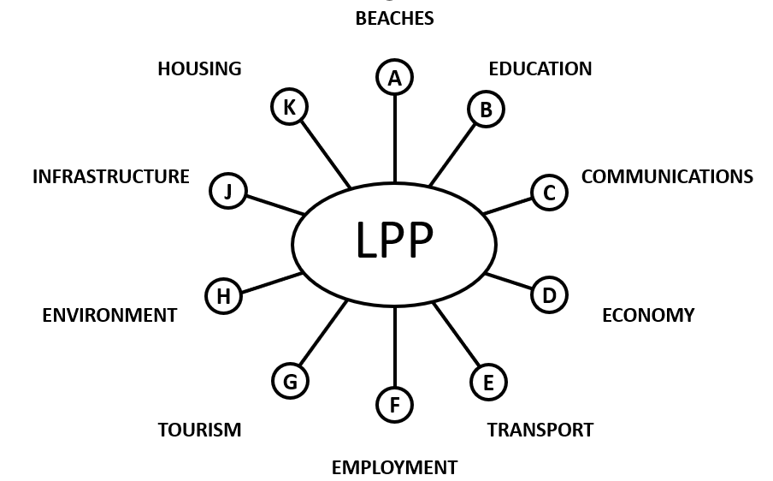
- WhatsApp Community Consultation 2 Completed 3/3/24 – Feedback from 177 people
- Panel displays
  - Colvend Family Gala 25/5/24 (500 present)
  - Colvend Public Hall End May – September e.g. 150 people present at the FLS Consultation
  - Kippford Village Hall 29/9/24 (Corresponded to opening of the Kippford Nature Reserve Memorial Shelter 150 present)
- Postal drop to 100% of residents’ properties also communicated via the 5 WhatsApp groups, facebook page, website & 5 Community Noticeboards.
- HNDA Survey 2/12/24 Paper & electronic communications – Feedback from 344 people
- Draft LPP published on website for comment. 23/12/24
- Went through 7 published revisions until 20/1/25
- Multiple warnings on WhatsApp about the consultation closing date.
- Neighbouring Community Council consultations completed – 28/4/25

Stakeholder Consultations (Involving face to face discussions with the LPP Team)
- Colvend School
- National Trust Scotland
- Solway Coast And Marine Project
- Forest & Land Scotland
- Royal Society for the Protection of Birds
- Southern Upland Partnership
- Solway Yacht Club
- Church of Scotland
- South of Scotland Community Housing Trust

